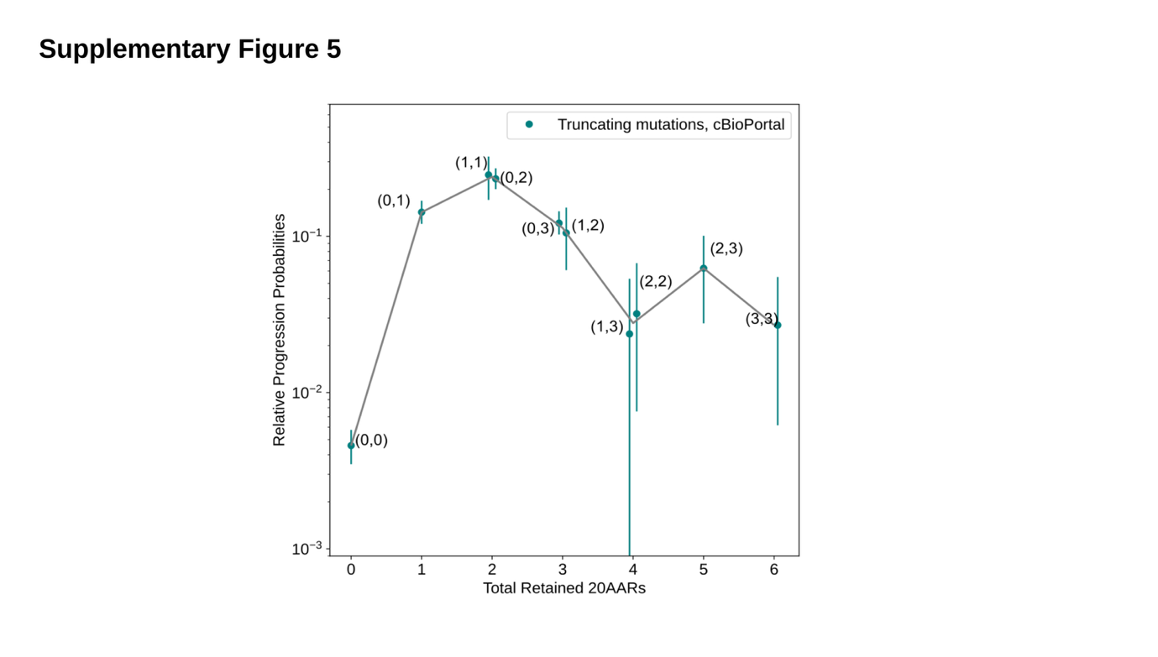Supplementary Figure 5. Progression probabilities of APC genotypes in cBioPortal Cohort.
The relative progression probability of different APC biallelic mutant genotypes, ${\tilde{p}}_{(M,N)}$, is plotted against the total number of 20AARs retained across both alleles. The frequencies of genotypes were calculated from sequence data of MSS primary CRCs in the cBioPortal cohort without copy-number alterations on APC (n=1,041, Methods). Whiskers for 95% confidence intervals (bootstrapping). The grey line is the weighted average of the progression probability over all genotypes which result in a given number of retained 20AARs. Genotype (M,N) denotes a truncating mutation in region R_{M} in one allele and a truncating mutation in region R_{N} in the other allele. Regions are defined relative to the 20AAR domains, such that a single truncating mutation in region R_{i} leaves i intact 20AAR repeats, where i can be 0,1,2 or 3. The total number of 20AARs is given by M+N.

